**Application Programming Interface (API)**

API is a software interface that allows two applications to interact with each other without any user intervention. It is a code that allows two different software’s to communicate and exchange data with each other.

**API Call**

An API call is the process of a user application submitting a request to an API and that API retrieving the requested data from the external server and sending it back to the user.

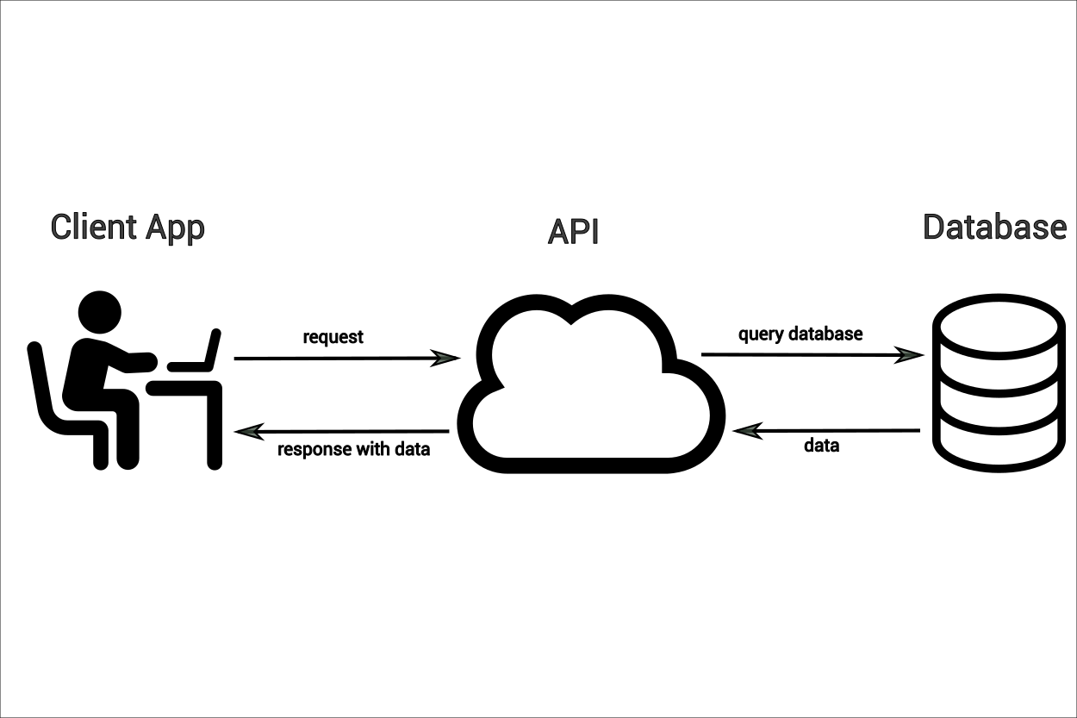

**How an API Works?**

API calls travel from a client to an API endpoint.

API work in these stages: -

* Make the call to the API via its Uniform Resource Identifier (URL).
* API makes a call to some external program for data.
* API gets a response from the external program.
* API gives the data to the initial requesting program

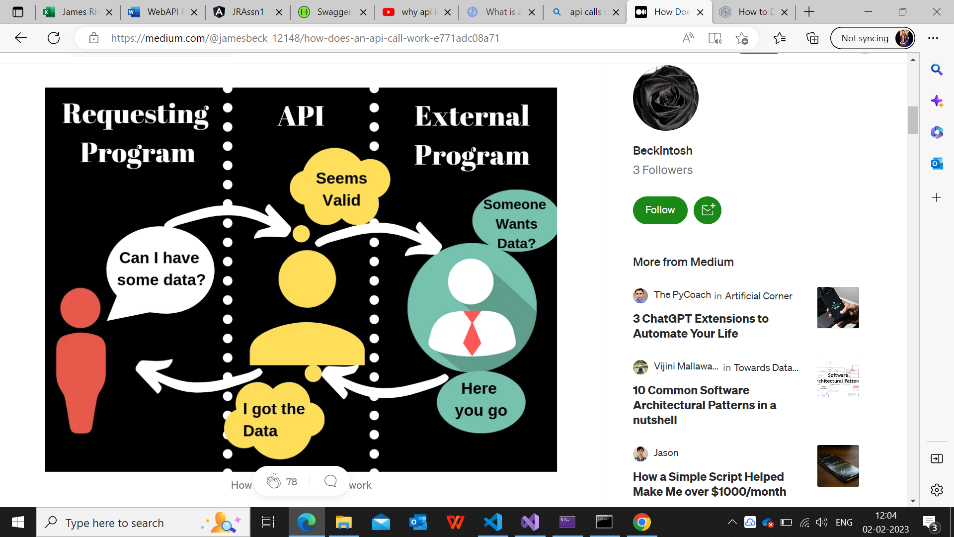

Requests have a type to which they adhere

GET – Requesting some data

PUT – Requesting to put new data

POST – Requesting to update the data

DELETE – Requesting to delete the data

**How to deal with slow APIs?**

APIs is getting slow due to following reasons

* API payload size for request is huge
* Retrieve multiple types of information from different databases
* Multiple API calls simultaneously

## **Quick ways to scale a slow web application**

* Adding more CPU/RAM

There are two ways for scalability

(i) **Vertical scalability**: - We can make the server bigger by adding CPU/RAM but there is a limit to how much CPU and RAM one server can have.

(ii) **Horizontal scalability**: - It means we can add more servers. It allows scaling even if vertical scalability does not work

* Add cache to web app

It saves some calculated data and returns them instead of calculating again every time.

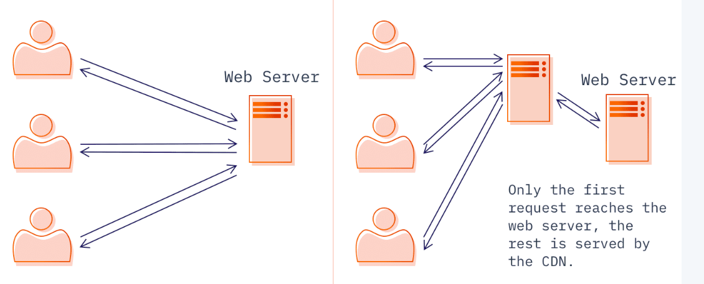 s